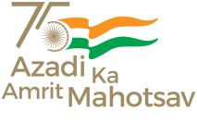
OFFICE OF THE PROGRAMME OFFICER
MAHATMA GANDHI NATIONAL RURAL EMPLOYMENT GUARANTEE ACT
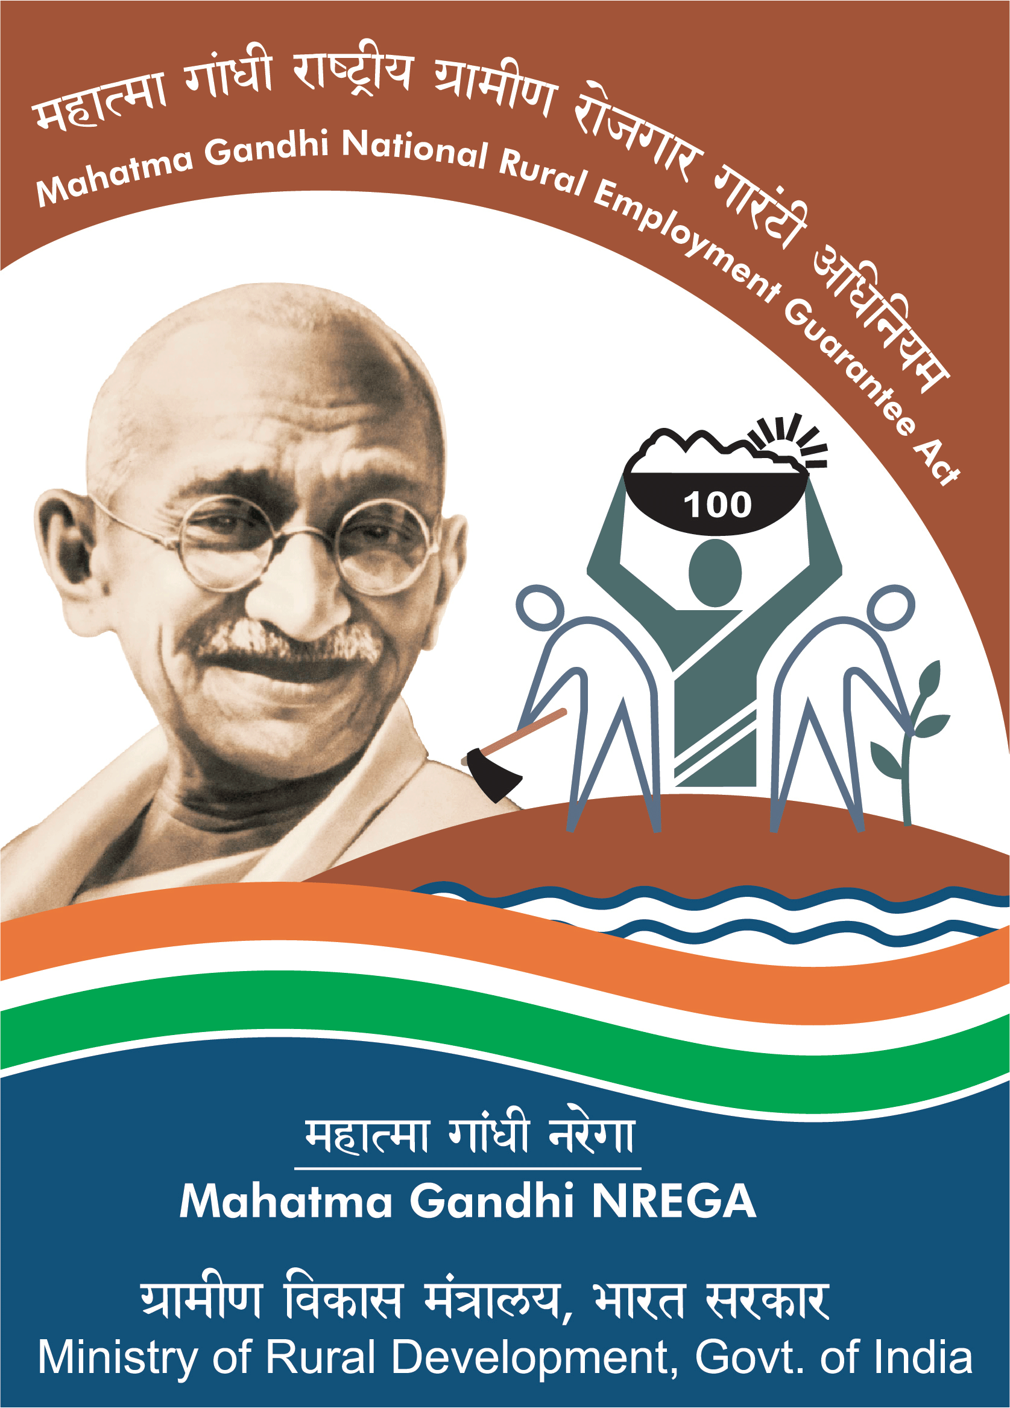
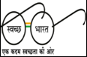
&
BLOCK DEVELOPMENT OFFICER
KHAWZAWL R.D. BLOCK : KHAWZAWL

No.B.11016/3/2022 - BDO(KZ)/ 9 : Dated Khawzawl, the 5th Dec., 2022

WORK ORDER NO- 9 OF 2022– 2023
DECEMBER, 2022

MGNREGA Khawzawl RD Block hnuaia VEC te hnenah ni 10 days hnathawhna tur Rs 1,99,61,110/-(Rupees One crore ninety nine lakh sixty one thousand one hundred ten) chiah pek a ni a, Job Card a hming chuangte chauhin hna an thawk tur a ni a, mi pakhat tan ni khatah Rs. 233/-zelin hlawh pek tur a ni. Hna thawh turte hi Annexure-I ah tar lan a ni e.
Hnathawh hunchhung atan Date 7th December, 2022 – 17th December, 2022 ruahman a ni a, hemi hunchhung hian hna hi tha taka thawh zawh ngei ngei tur a ni. VEC tin ten hnathawh hma, hnathawh lai, hnathawh zawh thla lak zel tur a ni a, hnathawhna hmunah Citizen Information Board/Sign Board tha taka siam zel tur a ni.

Hna kan thawh zawhah thlalak te hi Photo Paper – A4 size in (Before,During & After) thlalak thehluh tur a ni a, Soft Copy hi DEO hnenah thehluh bawk tur a ni a, Muster Roll, Completion Certificate leh Inspection Certificate te nen Programme Officer hnenah thehluh tur a ni a, heng tello hi chuan Pay Order pek chhuah theih a ni lo ang.

Job Card holder-te inhlawhna pawisa hi e-Fms hmangin Bank kaltlanga lak zel tur a ni.

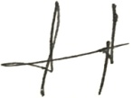

(LALTHAKIMA CHHANGTE)
Programme Officer
Mahatma Gandhi National Rural Employment Guarantee Act
&
Block Development Officer
Khawzawl R.D Block

Memo No.B.11016/3/2022 - BDO(KZ)/ 9 : Dated Khawzawl, the 5th Dec., 2022
Copy to :
- The District Programme Officer, MGNREGA Khawzawl District for information.
- All Chairman,VEC, MGNREGA under Khawzawl RD Block for information and necessary action.
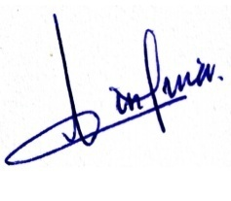
- All Chairman,VMC, MGNREGA under Khawzawl RD Block for information and necessary action.
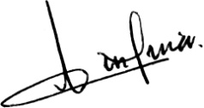
- All VLAA, MGNREGA under Khawzawl RD Block for information and necessary action.
- Relevant file.

Programme Officer
Mahatma Gandhi National Rural Employment Guarantee Act
&
Block Development Officer
Khawzawl R.D Block

