**OFFICE OF THE PROGRAMME OFFICER**

**MAHATMA GANDHI NATIONAL RURAL EMPLOYMENT GUARANTEE ACT**

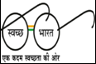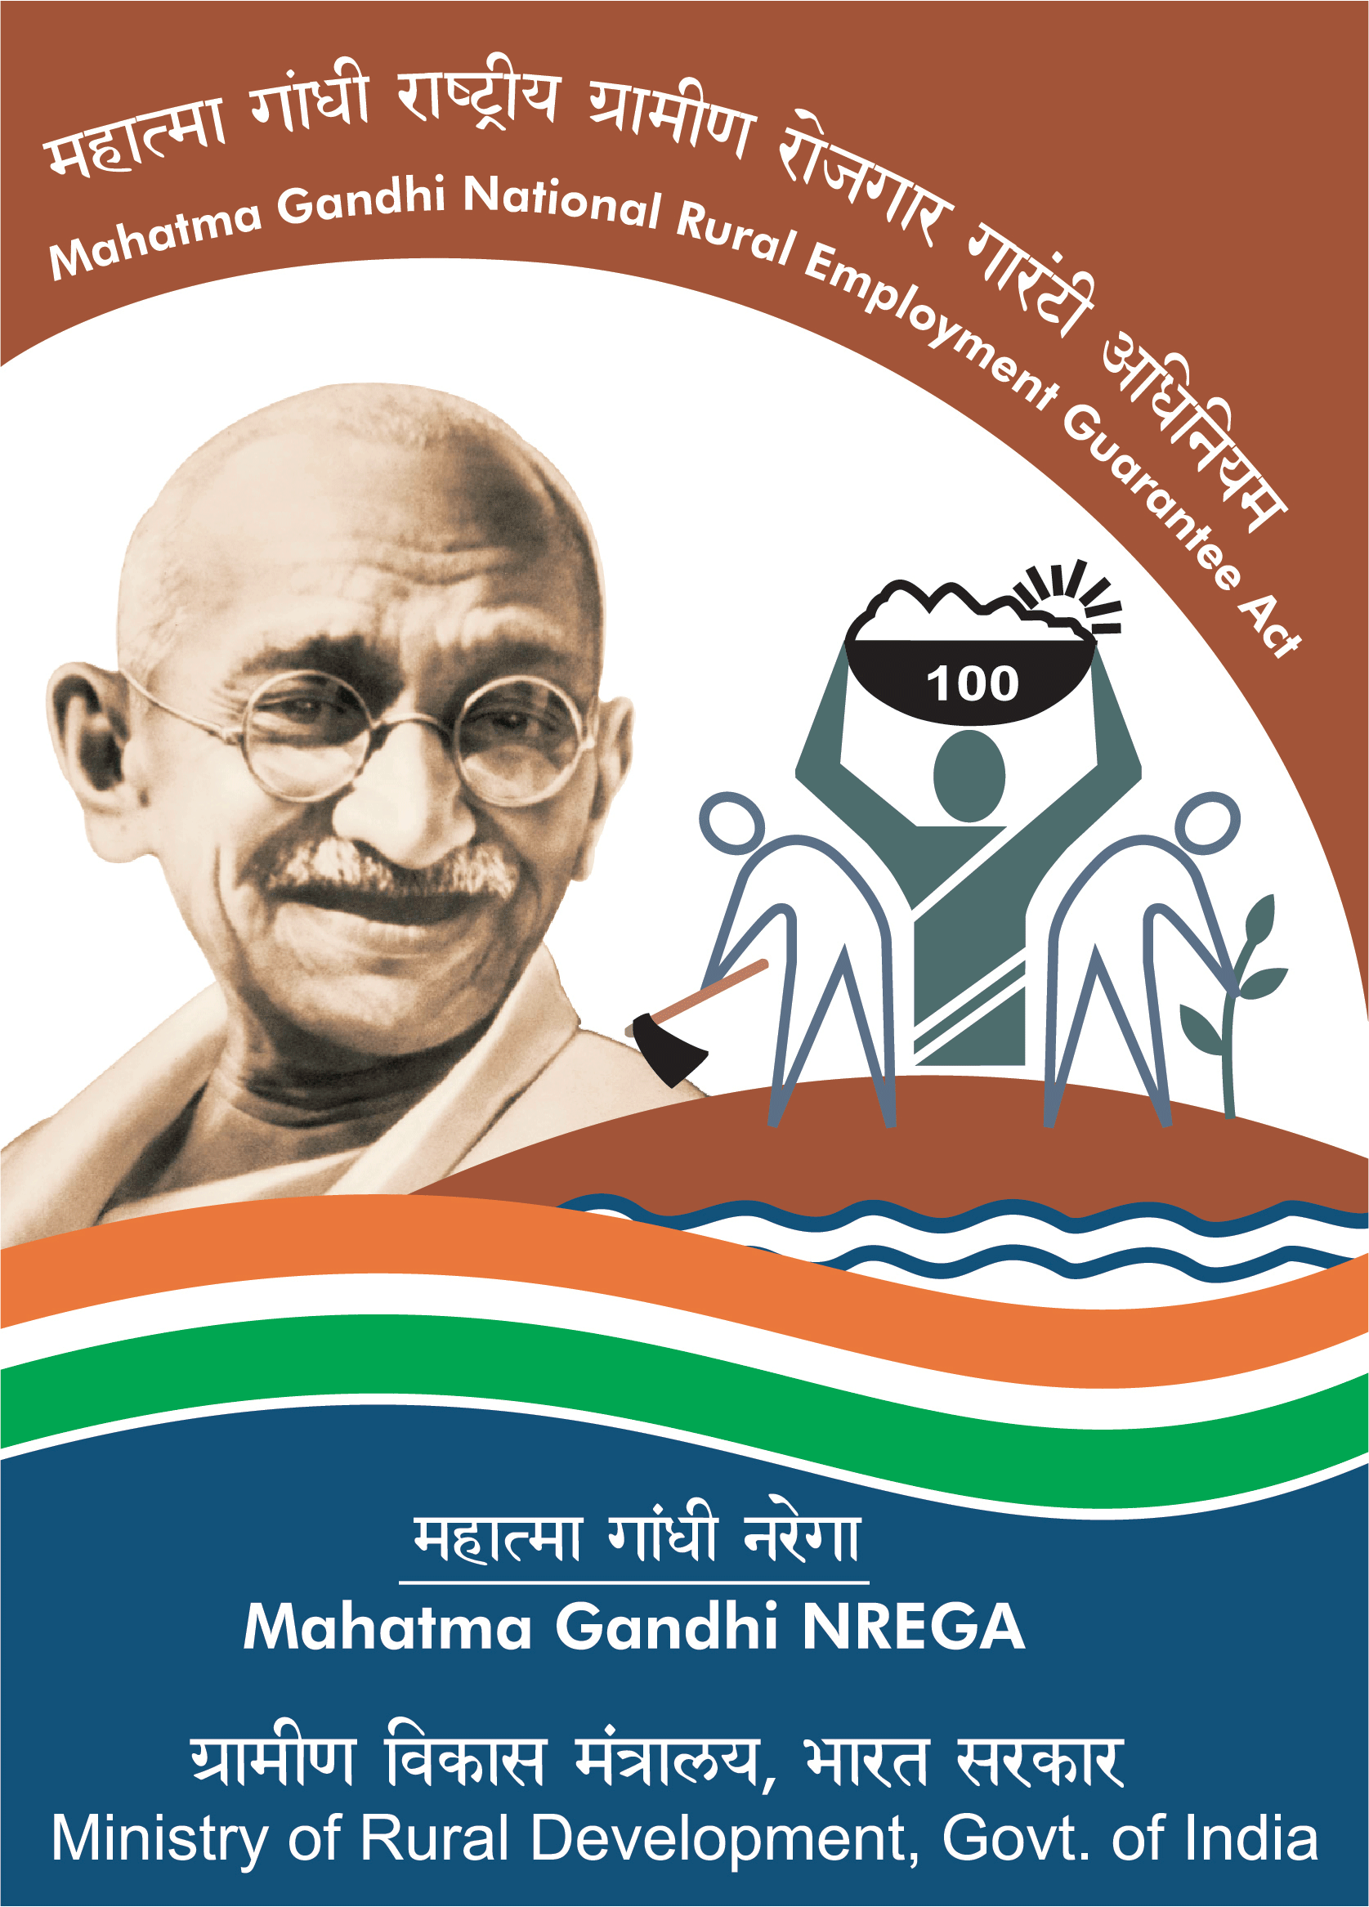**&**

**BLOCK DEVELOPMENT OFFICER**

**KHAWZAWL R.D. BLOCK : KHAWZAWL**

**No.B.11016/3/2022-BDO(KZ) : Dated Khawzawl, The 23th May, 2024**

**CORRIGENDUM**

Mahatma Gandhi NREGA, Wage Component Work Order No.B.11016/3/2022-BDO(KZ)/26 of Dt. 22.5.2024 a siam tawh ah, Dulte hi siam that a ni a, Annexure – a tarlan ang hian hman tur a ni.

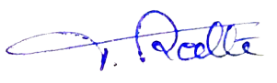

**( TIMOTHY R.LALHMANGAIHA)**

Programme Officer

Mahatma Gandhi National Rural Employment Guarantee Act

&

Block Development Officer

Khawzawl R.D Block

Memo No.B.11016/3/2022-BDO(KZ)/14 : Dated Khawzawl, The 26th April, 2023

Copy to :

1. The District Programme Officer, MGNREGA Khawzawl District for information.
2. Concerned Chairman,VEC, MGNREGA under Khawzawl RD Block for information and necessary action.
3. 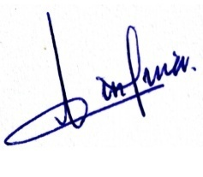Concerned Chairman,VMC, MGNREGA under Khawzawl RD Block for information and necessary action.
4. 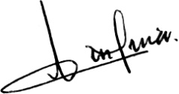Concerned VLAA, MGNREGA under Khawzawl RD Block for information and necessary action.
5. Relevant file.

Programme Officer

Mahatma Gandhi National Rural Employment Guarantee Act

&

Block Development Officer

Khawzawl R.D Block