**OFFICE OF THE PROGRAMME OFFICER**

**MAHATMA GANDHI NATIONAL RURAL EMPLOYMENT GUARANTEE ACT**

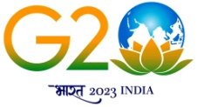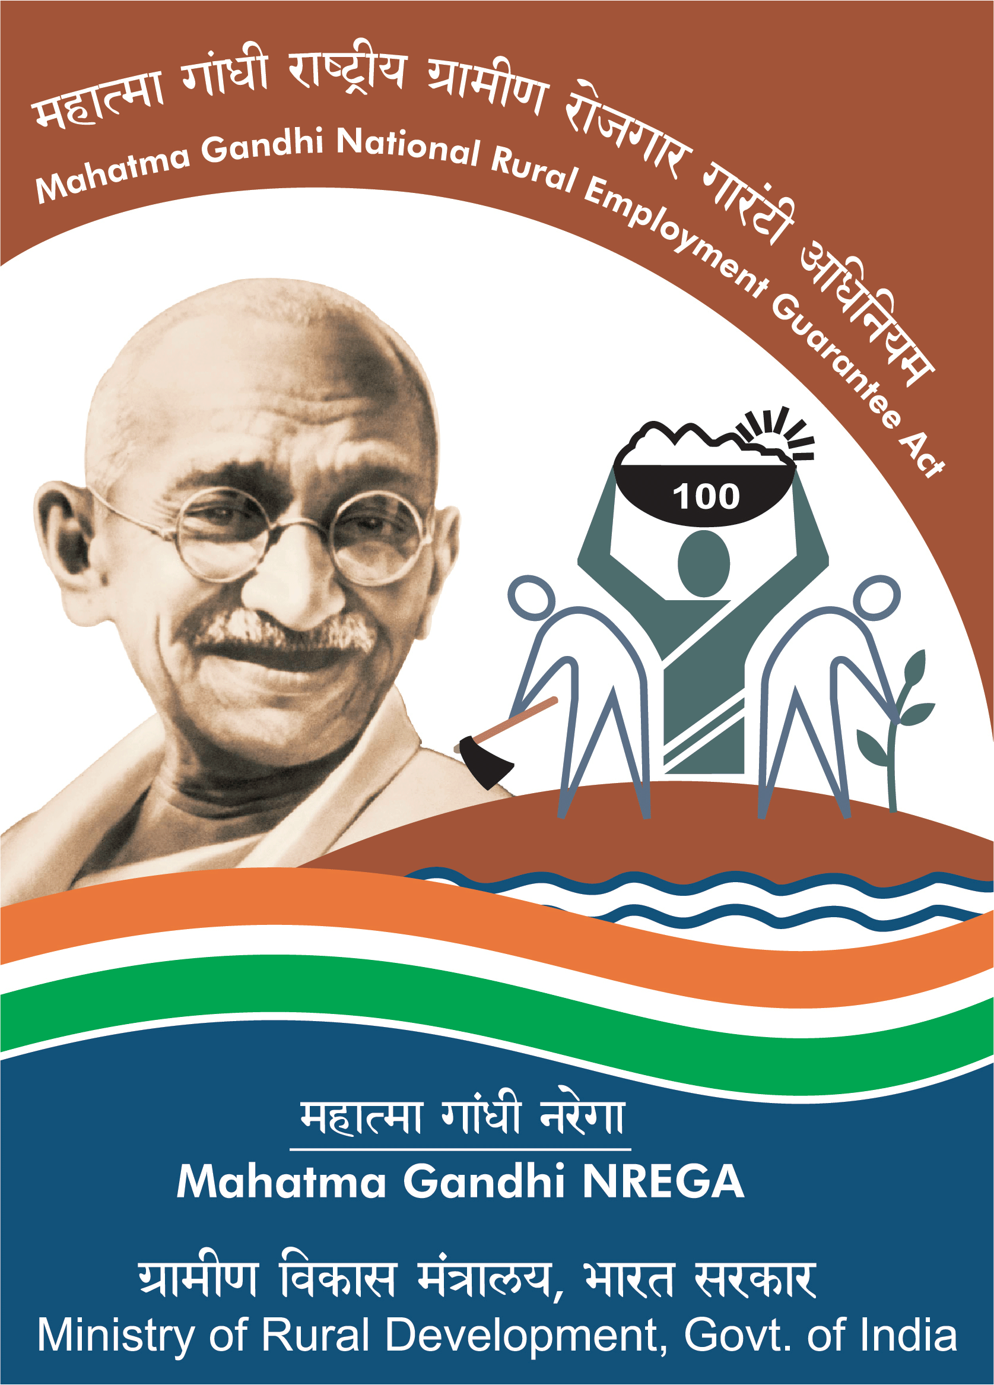**&**

**BLOCK DEVELOPMENT OFFICER**

**KHAWZAWL R.D. BLOCK : KHAWZAWL**

**No.B.11016/3/2022 - BDO(KZ)/ : Dated Khawzawl, the 22nd January, 2024**

**CORRIGENDUM**

Mahatma Gandhi NREGA, Wage Component Work Order No.B.11016/3/2022-BDO(KZ)/ of Dt.22.1.2024 a siam tawh ah, Tualpui hi siam that a ni a, Annexure a tarlan ang hian hman tur a ni.

**Sd/- LALTHAKIMA CHHANGTE**

Programme Officer

Mahatma Gandhi National Rural Employment Guarantee Act

&

Block Development Officer

Khawzawl R.D Block

**Memo**  **No.B.11016/3/2022 - BDO(KZ)/ : Dated Khawzawl, the 22nd January, 2024**

Copy to :

1. The District Programme Officer, MGNREGA Khawzawl District for information.
2. All Chairman,VEC, MGNREGA under Khawzawl RD Block for information and necessary action.
3. 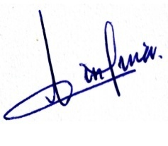All Chairman,VMC, MGNREGA under Khawzawl RD Block for information and necessary action.
4. 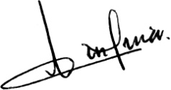All VLAA, MGNREGA under Khawzawl RD Block for information and necessary action.
5. Relevant file.

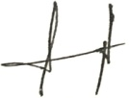

**(LALTHAKIMA CHHANGTE)**

Programme Officer

Mahatma Gandhi National Rural Employment Guarantee Act

&

Block Development Officer

Khawzawl R.D Block